D597 Task 1 – Relational Database Design and Implementation

Part 1: Design Document

A. Business Problem and Database Solution

A1. Business Problem Description
Healthcare organizations manage large volumes of patient data, including demographics, medical conditions, medications, allergies, and appointment history. Without a centralized and structured database, it becomes difficult to track patient conditions, identify high-risk patients, schedule follow-ups, and support data-driven clinical decisions. Manual or unstructured systems increase the risk of data inconsistency, delayed care, and inefficient resource utilization.
The selected scenario focuses on managing medical records for patients to improve healthcare monitoring, follow-up planning, and operational efficiency.

A2. Proposed Data Structure
To solve this problem, a relational database will be used, implemented using PostgreSQL as the Database Management System (DBMS).
The database will store patient-related information in structured tables with clearly defined columns, data types, and constraints. PostgreSQL is chosen due to its ACID compliance, strong data integrity, advanced querying capabilities, and scalability for handling large datasets.

A3. Justification for Database Solution
A relational database solution ensures: - Centralized storage of patient medical records - Data consistency through constraints and data types - Efficient querying for medical analysis and reporting - Scalability to handle large volumes of patient records
Using PostgreSQL directly addresses the business problem by enabling healthcare staff to retrieve patient insights quickly and accurately, improving decision-making and patient care.

A4. Use of Business Data
The medical data stored in the database will be used to: - Identify patients requiring follow-up care - Analyze medical conditions and medication usage - Support hospital resource planning - Generate reports for clinical and administrative purposes

B. Logical Data Model
The logical data model for this project is represented using a normalized relational structure implemented in PostgreSQL. Instead of storing all information in a single table, the dataset has been decomposed into multiple related entities to ensure data integrity, eliminate redundancy, and support scalable database design.
The database consists of the following primary entities:

1. Patients
This is the central entity that stores core patient demographic information. Each patient is uniquely identified by a primary key.
- patient_id – INTEGER (Primary Key)
- name – VARCHAR(100)
- date_of_birth – DATE
- gender – CHAR(1)
- tracker – VARCHAR(50)

2. Medical_Conditions
This entity stores patient medical conditions. A patient can have multiple medical conditions, establishing a one-to-many relationship with the Patients table.
- condition_id – INTEGER (Primary Key)
- patient_id – INTEGER (Foreign Key)
- condition_name – VARCHAR(100)

3. Medications
This entity captures medications associated with each patient. A patient may have multiple medications, forming a one-to-many relationship.
- medication_id – INTEGER (Primary Key)
- patient_id – INTEGER (Foreign Key)
- medication_name – VARCHAR(100)

4. Allergies
This entity stores allergy-related information for each patient. A patient can have multiple allergies.
- allergy_id – INTEGER (Primary Key)
- patient_id – INTEGER (Foreign Key)
- allergy_name – VARCHAR(100)

5. Appointments
This entity records patient appointment history. Each patient can have multiple appointments over time.
- appointment_id – INTEGER (Primary Key)
- patient_id – INTEGER (Foreign Key)
- appointment_date – DATE

Relationships
The database follows a one-to-many (1:M) relationship model:
- One patient can have many medical conditions
- One patient can have many medications
- One patient can have many allergies
- One patient can have many appointments
All relationships are established using foreign keys referencing the patient_id in the Patients table, ensuring referential integrity.

Model Justification
This normalized logical model eliminates repeating groups and ensures that each attribute is atomic, satisfying First Normal Form (1NF). It improves data consistency, reduces redundancy, and enhances query performance for analytical and reporting purposes.

Logical Data Model Screenshot:
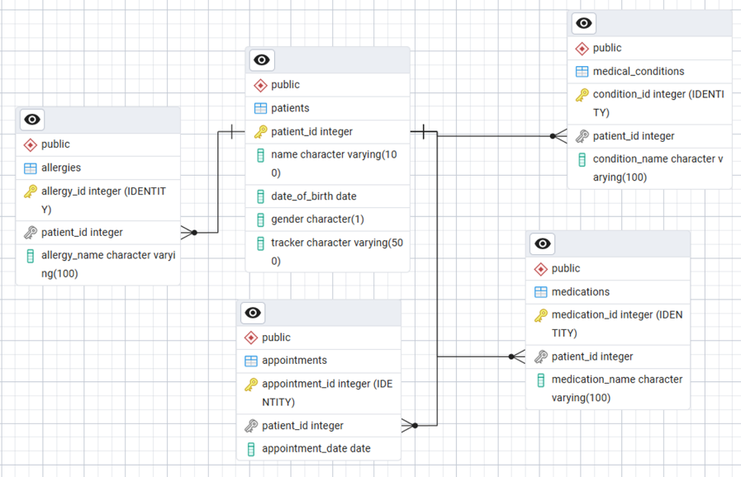

(A screenshot of the Entity-Relationship Diagram (ERD) representing the relationships between Patients, Medical_Conditions, Medications, Allergies, and Appointments tables has been included below.)

C. Database Objects and Storage
The database includes the following objects: - Tables: medical_records - Columns: Defined with appropriate data types such as INTEGER, DATE, and VARCHAR - Constraints: Primary key constraint on patient_id, NOT NULL constraints for essential fields - Indexes: Indexes may be created on frequently queried columns such as last_appointment_date and medical_conditions
These objects ensure structured storage, integrity, and optimized access to data.

D. Scalability Considerations
The proposed database design addresses scalability by: - Using indexing to improve query performance - Supporting large datasets (100,000+ records) - Allowing future normalization into multiple related tables - Leveraging PostgreSQL’s ability to scale vertically and horizontally
This ensures the system can grow with increasing patient data and organizational needs.

E. Privacy and Security Measures
To protect sensitive healthcare data, the following security measures should be implemented: - Role-based access control (RBAC) - Secure authentication for database users - Data encryption at rest and in transit - Regular database backups and recovery plans - Audit logging to track data access and changes
These measures help ensure compliance with data privacy standards and protect patient confidentiality.

Part 2: Implementation

F. Database Implementation and Queries

F1. Database Instance Creation
A PostgreSQL script was developed to create the database instance and define the required table structure based on the logical data model.
The database instance is named D597_Task_1.
Database Creation Script
-- Create Database Instance
CREATE DATABASE "D597_Task_1";
After creating the database, the following script was executed to create the primary table.

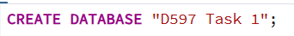

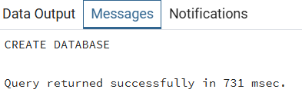
Table Creation Script:
CREATE TABLE medical_records (
patient_id INT PRIMARY KEY,
name VARCHAR(100) NOT NULL,
date_of_birth DATE NOT NULL,
gender CHAR(1) NOT NULL,
medical_conditions VARCHAR(50),
medications VARCHAR(10),
allergies VARCHAR(50),
last_appointment_date DATE,
tracker VARCHAR(500)
);
This script establishes the relational structure required to store patient medical data while enforcing entity integrity through the primary key constraint.
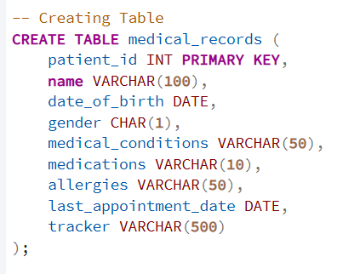
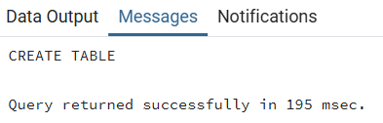

F2. Data Import from CSV
The CSV file containing medical records was successfully imported into the medical_records table using PostgreSQL’s COPY command, which is designed for efficient bulk data loading (PostgreSQL Global Development Group, n.d.-a).
Corresponding Script: CSV Data Import
-- Importing CSV file
COPY medical_records
FROM 'C:/Program Files/PostgreSQL/18/data/D597 Task 1 Dataset 3_medical_records.csv'
DELIMITER ','
CSV HEADER;
A screenshot of the COPY command script and its successful execution result has been included as evidence.
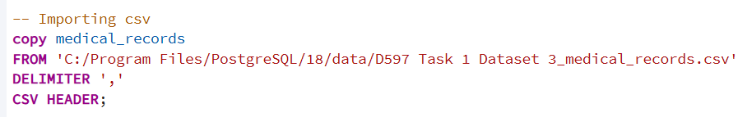
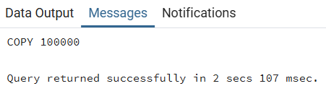

F3. Business Queries

Query 1: Patients by Medical Condition
This query retrieves the number of patients grouped by medical condition.
SELECT medical_conditions, COUNT(*) AS total_patients
FROM medical_records
GROUP BY medical_conditions;
Corresponding Query (Query 1): Patients by Medical Condition
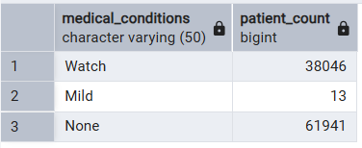

Query 2: Patients Requiring Follow-Up
This query identifies patients who have reported allergies and groups them based on allergy type.
SELECT allergies, COUNT(*) AS patient_count
FROM medical_records
WHERE allergies <> 'None'
GROUP BY allergies
ORDER BY patient_count DESC;
Corresponding Query (Query 2): Patients with Allergies
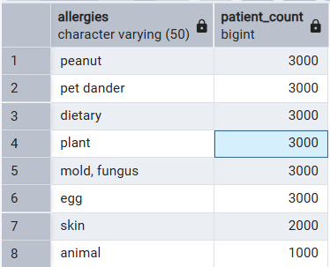

Query 3: Gender-Based Patient Distribution for Resource Planning
This query analyzes patient distribution by gender, helping healthcare administrators plan gender-specific resources and services more effectively.

SELECT gender,COUNT(*) AS patient_count
FROM medical_records
GROUP BY gender;
Corresponding Query (Query 3): Gender-Based Patient Distribution
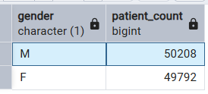

F4. Optimization
Indexes were created on frequently queried columns to improve query performance and reduce execution time (PostgreSQL Global Development Group, n.d.-c). The execution time of the query was measured before and after applying indexes using the EXPLAIN ANALYZE command, which provides detailed query execution metrics (PostgreSQL Global Development Group, n.d.-b).

Corresponding Script: Index Creation
-- F4. Optimization
CREATE INDEX idx_medical_conditions
ON medical_records(medical_conditions);
CREATE INDEX idx_last_appointment
ON medical_records(last_appointment_date);

Corresponding Query Optimization (Before Indexing)
-- Before Indexes (execution time)
EXPLAIN ANALYZE
SELECT medical_conditions, COUNT(*) AS total_patients
FROM medical_records
GROUP BY medical_conditions;
Before Indexing Execution Result:
(Inserted screenshot showing EXPLAIN ANALYZE output with execution time before index creation)
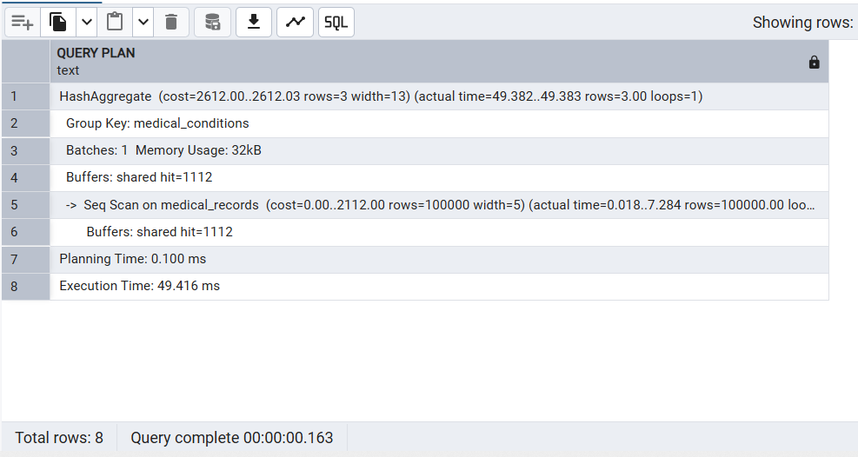

Corresponding Query Optimization (After Indexing)
-- After Indexes (execution time)
EXPLAIN ANALYZE
SELECT medical_conditions, COUNT(*) AS total_patients
FROM medical_records
GROUP BY medical_conditions;
After Indexing Execution Result:
(Inserted screenshot showing EXPLAIN ANALYZE output with improved execution time after index creation)
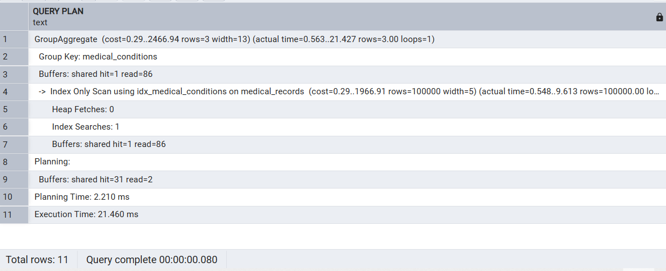

Part 3: Presentation
The PostgreSQL database solution was presented through a recorded video presentation. The video clearly captures both the presenter and the fully functioning PostgreSQL environment for the entire duration of the presentation.
During the presentation, the following components were demonstrated live:
- Database design and table structure
- Successful execution of SQL queries
- Index creation and query optimization process
- Execution results before and after optimization
- Explanation of how the queries address the identified business problem
The program was fully functional during the recording, and query outputs were shown as evidence of correct execution.
Panopto Presentation Link:
presentation_link

H. Sources

In-Text Citations
The COPY command was used for bulk data import into PostgreSQL as recommended in official documentation (PostgreSQL Global Development Group, n.d.-a).
The use of EXPLAIN ANALYZE for query performance evaluation follows PostgreSQL best practices (PostgreSQL Global Development Group, n.d.-b).
Indexing techniques were implemented to improve query efficiency based on PostgreSQL guidelines (PostgreSQL Global Development Group, n.d.-c).
Reference List
PostgreSQL Global Development Group. (n.d.-a). COPY. Retrieved March 27, 2026, from
https://www.postgresql.org/docs/current/sql-copy.html
PostgreSQL Global Development Group. (n.d.-b). EXPLAIN. Retrieved March 27, 2026, from
https://www.postgresql.org/docs/current/sql-explain.html
PostgreSQL Global Development Group. (n.d.-c). Indexes. Retrieved March 27, 2026, from
https://www.postgresql.org/docs/current/indexes.html

I. Professional Communication
This submission demonstrates professional communication through clear, well-structured, and technically accurate writing. All sections are logically organized with appropriate headings, making the document easy to follow and understand.
Technical terminology related to relational database design, PostgreSQL implementation, and data management has been used consistently and appropriately. Grammar, spelling, punctuation, and sentence structure have been carefully reviewed to ensure clarity and correctness.
The writing maintains a formal and professional tone suitable for academic and technical documentation. Each concept is explained clearly without unnecessary complexity, ensuring both readability and completeness.
Overall, this submission meets the expected standards of professional and academic communication.

